ABSTRACT TEMPLATE
Theme: HEIs at the Forefront of Transformative Extension: Advancing Evidence- Based, Inclusive, Sustainable, and Resilient Community Development
Instructions: Complete all sections. Select only one paper category and one thematic area. Use clear, evidence-based statements and avoid unsupported outcome or impact claims.

A. Paper Information
1. Title of the Extension Project Paper | ANAEROBIC DIGESTION (NVSU BIOGAS DIGESTER): Energy Generation and Utilization for Increased Swine Productivity
2. Author/s and Institutional Affiliation/s Note: Use an asterisk (*) after the name of the project leader. If the presenter is not the project leader, write “paper presenter” after the name | Sony P. Aquino*, Jenaida B. Aquino, June C. Quipo  Nueva Vizcaya State University – Bayombong Campus
3. Name and Email Address of Corresponding Author | Jenaida B. Aquino  jenaidabaquino@gmail. com
3. Paper Category | [ ] Completed Extension Project Paper  [ ] Ongoing Extension Project Paper
4. Thematic Area (choose 1 only) | [ ] Food Production, Agriculture, Fisheries, and Natural Resource Systems  [ ] Health, Nutrition, Wellness, and Community Care  [ ] Education, Literacy, Skills Development, and Lifelong Learning  [ ] Livelihood, Entrepreneurship, Cooperatives, MSMEs, and Local Economic Development  [ ] Environment, Climate Action, Disaster Risk Reduction, and Community Resilience

B. Extended Abstract Narrative
Guide: Write concise paragraphs under each required component.
5. Community or Sectoral Need Addressed
Briefly describe in not more than 150 words the validated community, institutional, or sectoral need addressed by the project.
The project addressed the pressing need of swine raisers for affordable, sustainable, and locally available energy and effective livestock waste management technologies. Swine production generates substantial amounts of animal waste that, when improperly managed, can cause environmental pollution, unpleasant odors, and risks to public health while also contributing to greenhouse gas emissions. At the same time, farmers face increasing costs of electricity, liquefied petroleum gas (LPG), and other conventional energy sources used for farm operations. The project responded to these challenges through the adoption of the Anaerobic Digestion (NVSU Model Anaerobic Digester), which converts swine manure into biogas for cooking, heating, pumping, and electricity generation while producing nutrient-rich by-products that can be utilized as organic fertilizer. The project also addressed the need for farmers' technical knowledge by providing capacity-building, technical assistance, and hands-on training on digester construction, operation, maintenance, and economic utilization.
6. Project Objectives
State the main objective/s of the extension project.
To enhance swine productivity and sustainability by providing training, technical assistance, expertise, and consultancy and promoting the adoption and utilization of the NVSU Model Anaerobic Digester for renewable energy generation, efficient waste management, and reduced farm operating costs.

7. Extension Methods, Strategies, or Activities Implemented
Describe in not more than 300 words the major extension approaches, methods, strategies, or activities implemented.
The project utilized a participatory, technology-transfer, and capacity-building approach to promote the adoption and sustainable utilization of the NVSU Model Anaerobic Digester among swine raisers. The major extension strategies and activities included:
- Technical Assistance, Expertise, and Consultancy – The NVSU College of Engineering, through the Department of Agricultural and Biosystems Engineering, provided free technical assistance, expertise, and consultancy to swine raisers and other stakeholders in the planning, site assessment, establishment, operation, maintenance, and improvement of anaerobic digesters.
- Training and Capacity Building – Training programs were conducted to strengthen the knowledge and skills of swine raisers on basic biogas digester construction, operation and maintenance, waste and by-product utilization, and the economic aspects of anaerobic digestion technology. The training employed lectures, discussions, demonstrations, and hands-on activities.
- Demonstration and Hands-on Learning – Actual demonstrations were conducted in partner/cooperator farms with established NVSU Model Anaerobic Digesters. Participants were given opportunities to observe the technology and directly participate in relevant activities, facilitating practical learning and confidence in technology adoption.
- Technology Demonstration and Adoption – Existing adopted anaerobic digesters served as technology showcase and learning sites, demonstrating the actual utilization of biogas for cooking, heating, pumping, and electricity generation.
- Performance Monitoring and Evaluation – Adopted digesters were monitored to assess biogas production, utilization, economic benefits, and operational performance. Gas flow monitoring and cost-and-return analysis were used to generate evidence on the effectiveness and viability of the technology.
- Networking and Partnership – The project strengthened collaboration among NVSU, swine raisers, cooperators, Municipal Agriculture Offices, and other stakeholders to facilitate technology dissemination, technical support, and wider adoption.
Through these integrated approaches, the project combined training, technical assistance, demonstration, consultancy, monitoring, and stakeholder collaboration to ensure that the technology was not only transferred but also effectively adopted and sustainably utilized by the target beneficiaries.
8. Key Outputs, Emerging Results, and Evidence of Outcomes, Adoption, or Utilization
Briefly present in not more than 300 words the documented outputs and emerging results of the project. Include available evidence of outcomes, adoption, utilization, capability-building, institutional change, or public value, if applicable. Claims must be supported by verifiable evidence.
a. Major Outputs or Emerging Results
The project generated significant outputs and emerging results in the areas of technology adoption, capacity building, renewable energy generation, waste management, and technical assistance. From 1999 to June 2024, the NVSU Department of Agricultural and Biosystems Engineering provided continuous extension support for the adoption of the NVSU Model Anaerobic Digester in Nueva Vizcaya and neighboring provinces.
A total of 76 NVSU Model Anaerobic Digesters were established and adopted as energy recovery and waste treatment facilities for swine production. These facilities benefited 205 households and 76 swine farms, demonstrating sustained utilization of the technology by the livestock sector. The adopted digesters had a combined capacity of approximately 1,765.60 m³ and generated an estimated 466.12 tons of biogas annually, which was utilized for cooking, heating, pumping, and electricity generation.
The project also strengthened the technical capabilities of swine raisers through training on basic biogas digester construction, operation and maintenance, waste and by-product utilization, and the economic aspects of anaerobic digestion technology. A total of 180 swine raisers were capacitated, with training activities receiving an overall evaluation rating of 4.90, indicating high participant satisfaction and perceived relevance.
Economic analysis further demonstrated the potential financial benefits of the technology. Selected anaerobic digesters generated annual revenues ranging from PhP 22,017.77 to PhP 588,238.55, with net incomes ranging from PhP 12,456.77 to PhP 359,913.55 and estimated payback periods of 2.50 to 4.31 years.
These documented results provide evidence that the NVSU Model Anaerobic Digester has been adopted, utilized, and sustained by swine raisers, while contributing to renewable energy generation, improved waste management, reduced dependence on conventional energy, and more sustainable swine production.
b. Evidence of Outcomes, Adoption, or Utilization
[Type response here. If not yet available, write: “Not yet available.”]
The project has generated clear evidence of technology adoption and utilization. As of June 2024, 76 NVSU Model Anaerobic Digesters had been adopted and installed in swine production farms in Nueva Vizcaya and neighboring provinces, including Quirino, Isabela, Ifugao, and provinces in the Ilocos Region. Of these, approximately 77.63% were installed in Nueva Vizcaya, demonstrating substantial local adoption of the technology.
The technology has directly benefited 205 households and 76 swine farms since its extension implementation in 1999 up to June 2024. The digesters are being utilized for cooking, heating, pumping, and electricity generation, while simultaneously providing a waste treatment facility for livestock manure.
Capability-building outcomes are also documented. A total of 180 swine raisers were capacitated in biogas digester construction, operation and maintenance, waste and by-product utilization, and the economic aspects of anaerobic digestion. The training received an overall post-evaluation rating of 4.90, indicating that participants considered the training timely and relevant to their needs.
The utilization of the technology has also produced measurable economic benefits. Annual revenues from 2.25, 16, and 60 m³ digesters were documented at ₱22,017.77, ₱110,232.37, and ₱588,238.55, respectively, with corresponding net incomes of ₱12,456.77, ₱55,735.81, and ₱359,913.55.
Overall, these documented adoption, utilization, capacity-building, beneficiary, and financial results demonstrate the project's contribution to renewable energy generation, sustainable waste management, improved swine production, reduced dependence on conventional fuels, and increased public value in rural communities.
c. Supporting Documents/Evidence Available
[Examples: attendance sheets, monitoring reports, photos, testimonials, adoption records, partnership agreements, policy issuances, utilization reports, or other proof.]
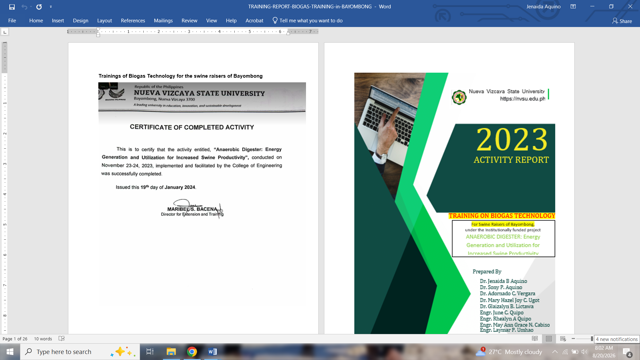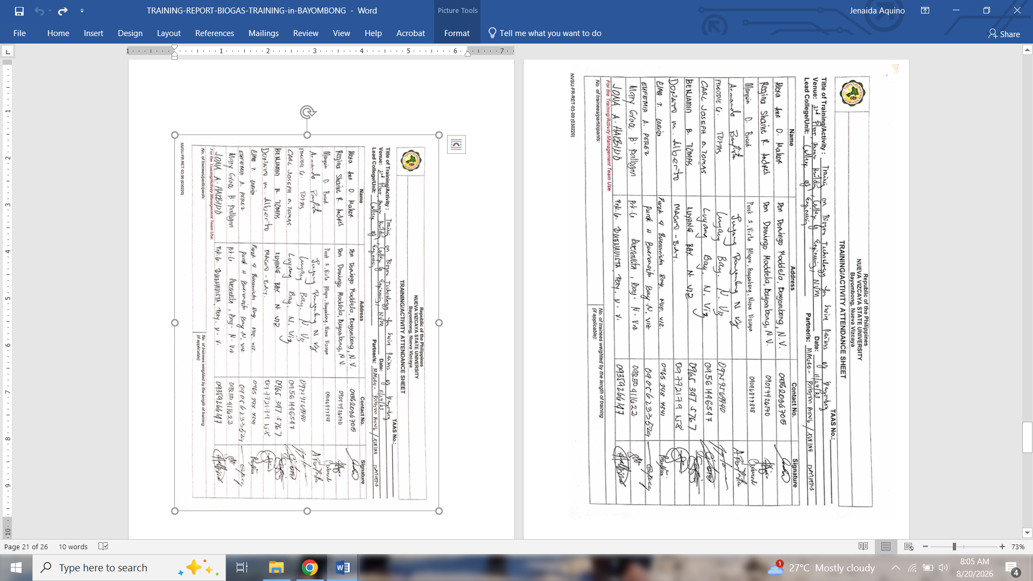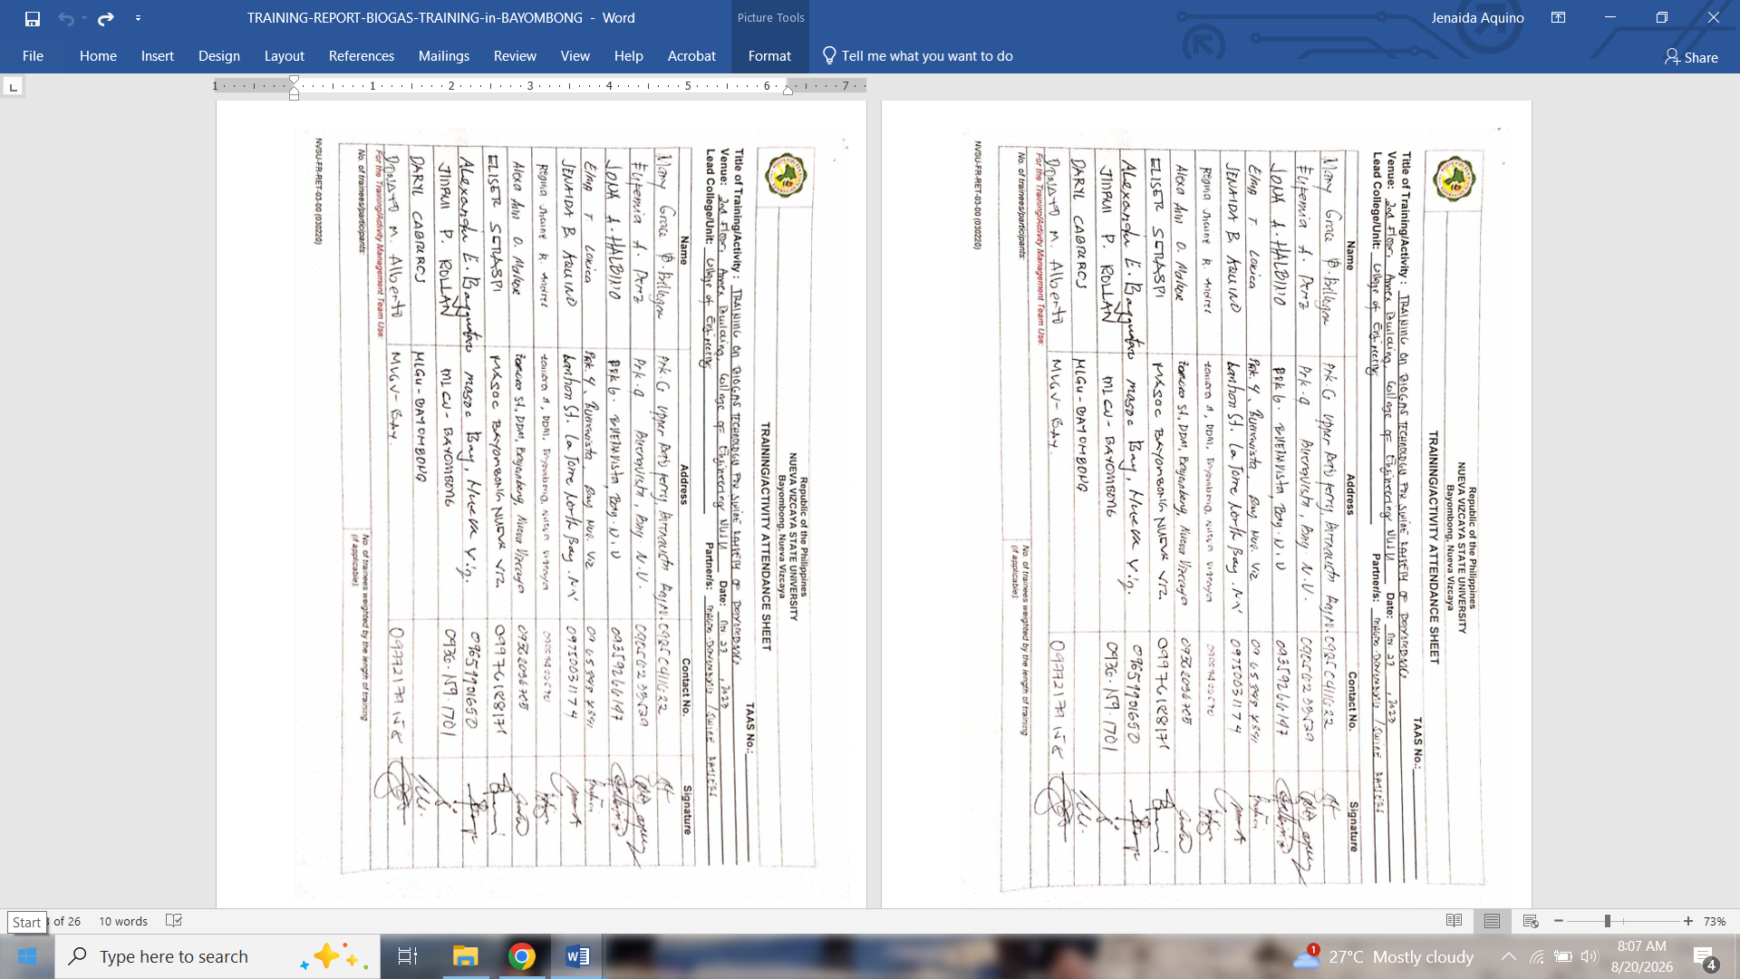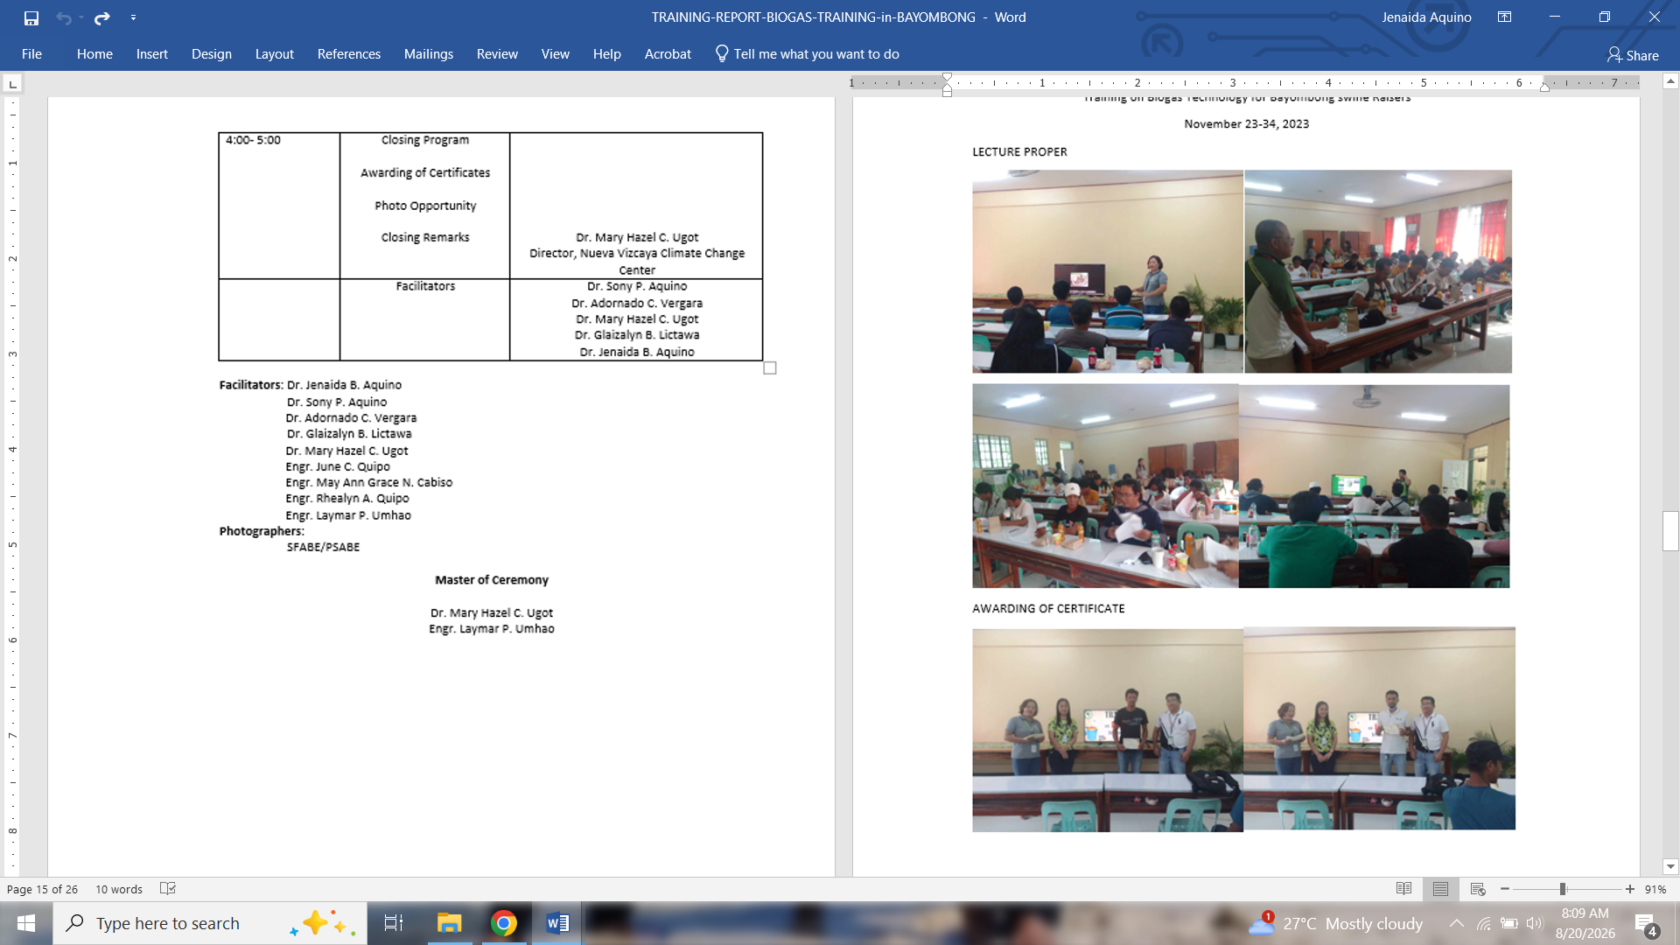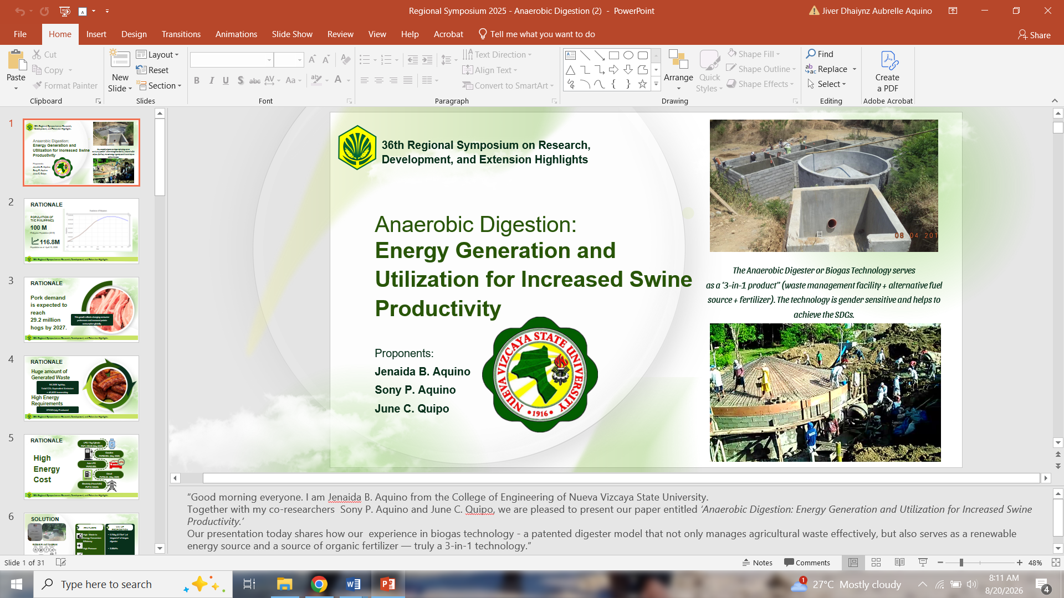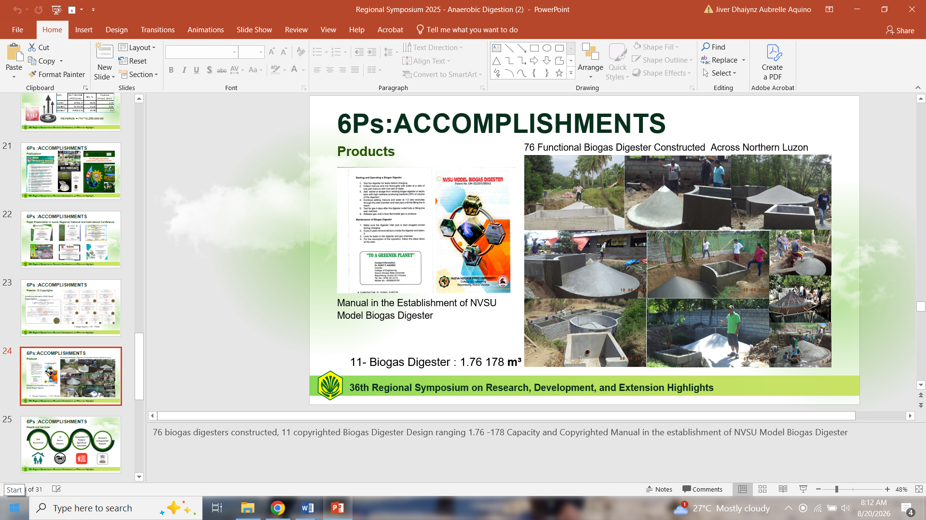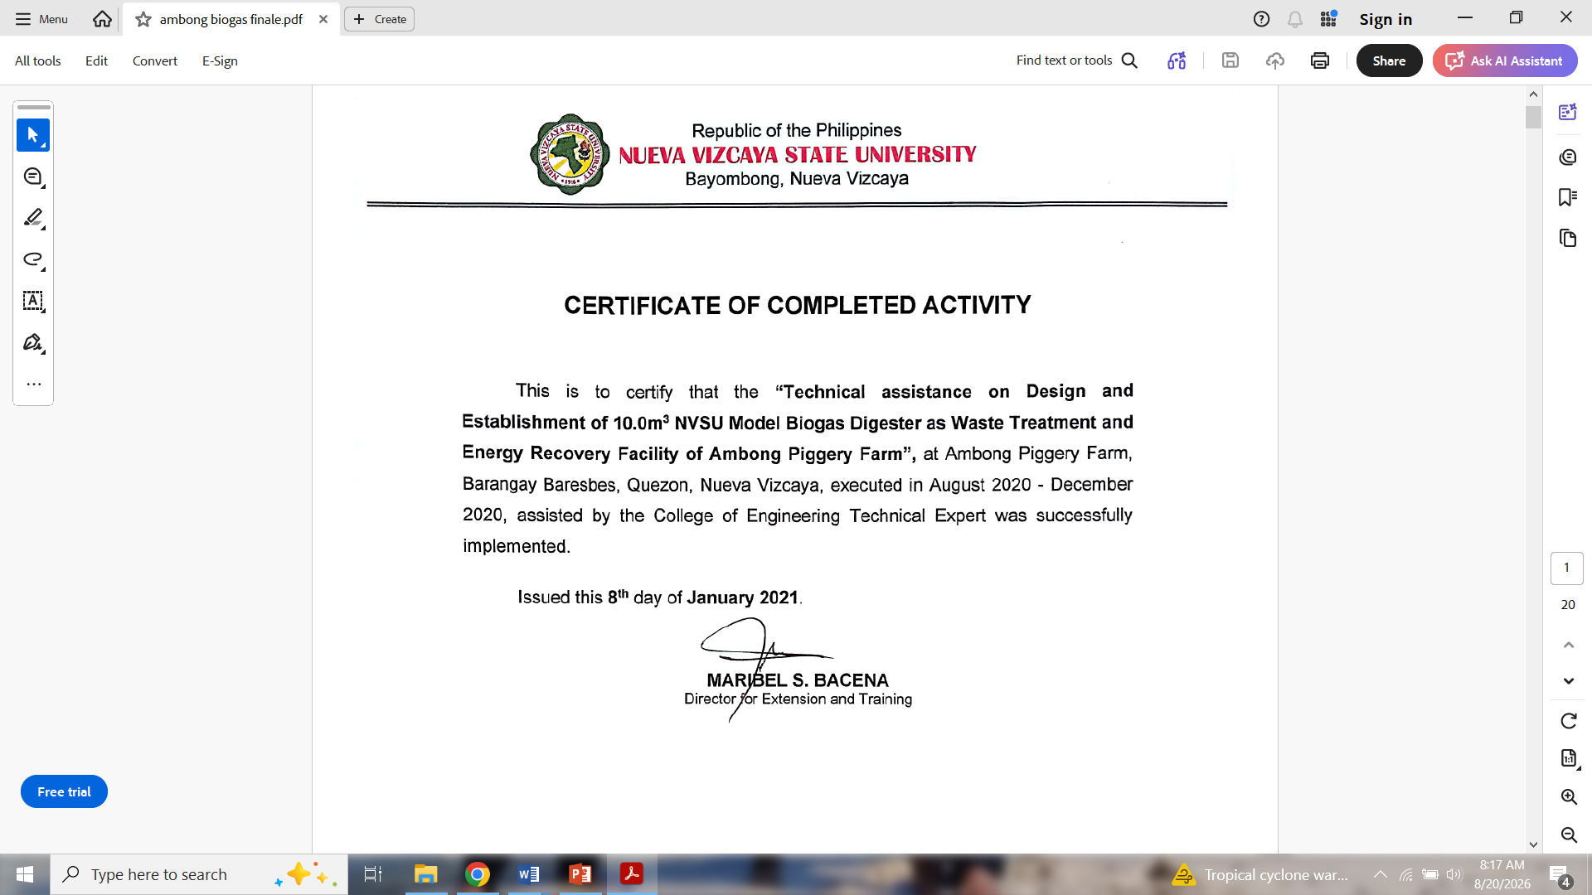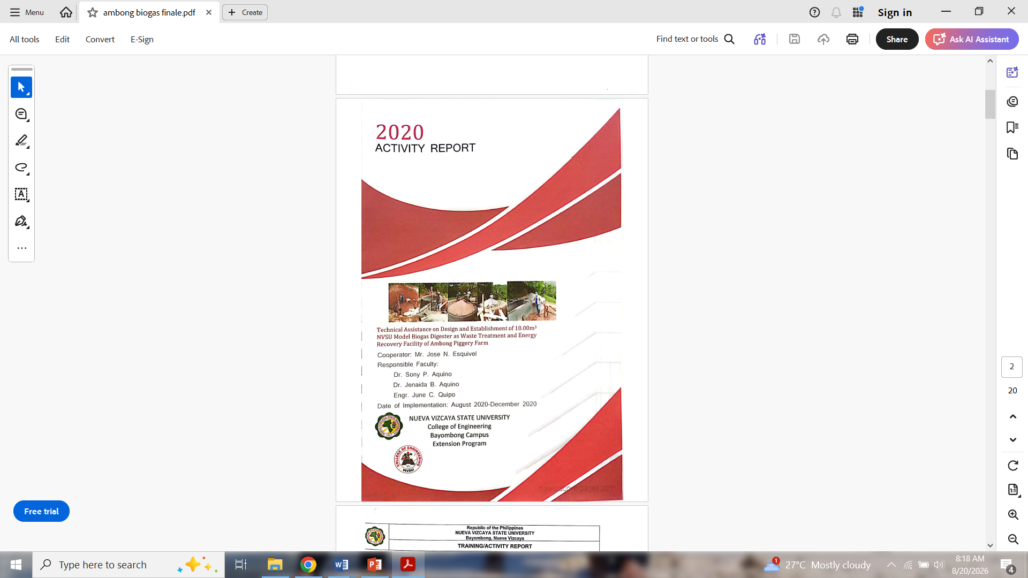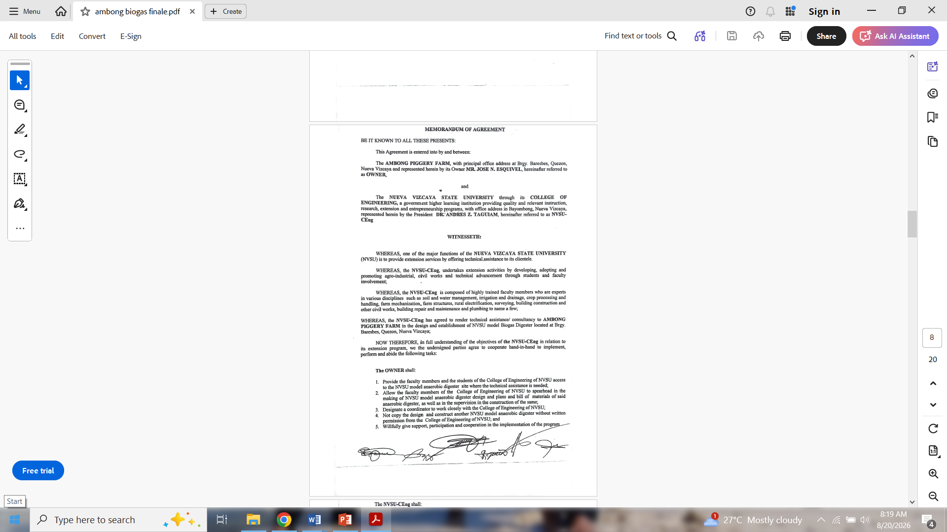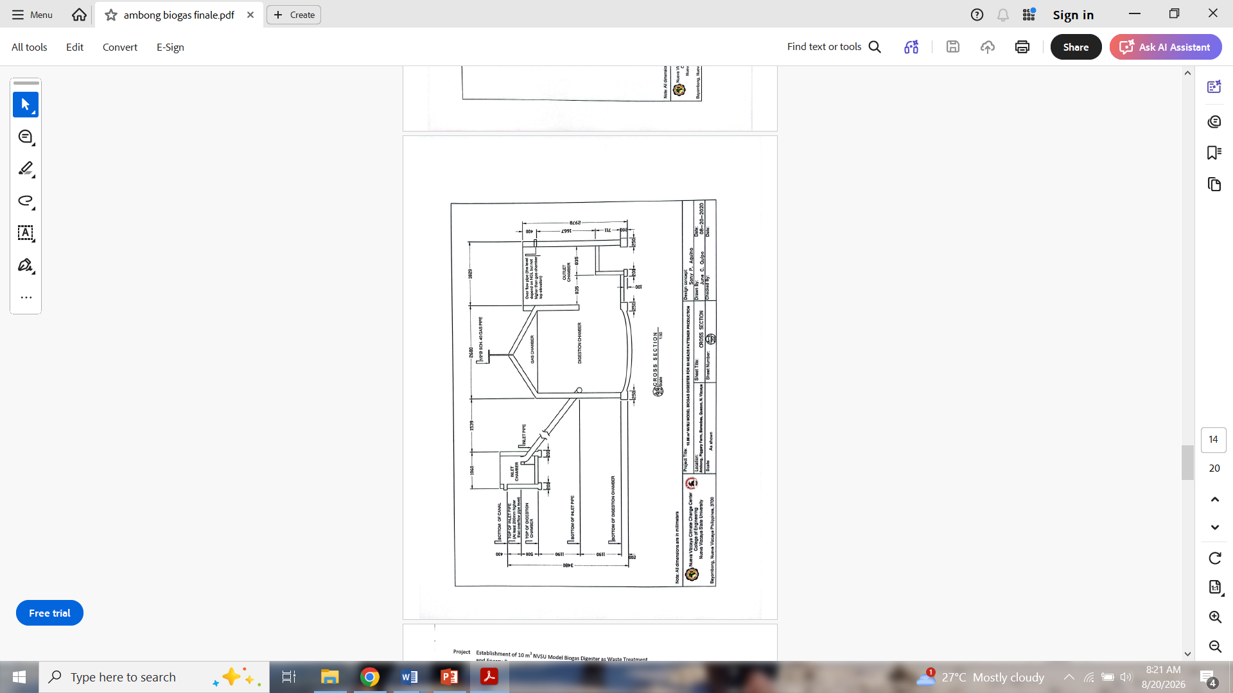
9. Sustainability Direction or Next Steps
Explain in not more than 150 words how the project will be sustained, institutionalized, scaled, or improved, or state the next steps for ongoing projects.
The project will be sustained through the continuous extension, technical assistance, monitoring, and promotion of the NVSU Model Anaerobic Digestion Technology among swine raisers and farming communities. NVSU’s College of Engineering Extension and Training Program will continue to work with the University Extension Program and Municipal Agriculture Offices to provide training on construction, operation and maintenance, waste and by-product utilization, and economic management of anaerobic digesters. The project will also strengthen monitoring and performance evaluation of existing installations to document gas production, economic benefits, and technology utilization.
The next steps include expanding technology adoption to additional swine farms and communities, improving technical assistance mechanisms, and strengthening partnerships with local government and agricultural stakeholders. The documented adoption of 76 digesters provides a foundation for further scaling of the technology.
C. Keywords
10. Keywords, three to five keywords: [Anaerobic Digester; renewable energy; financial analysis; Waste Management ; Circular Economy]
For PEMNet Abstract Review Committee Use Only:
[ ] Recommended for Acceptance
[ ] Not Recommended for Acceptance

Reviewed by: ___________________________________________________
Chair, PEMNet Scientific / Abstract Review Committee

